REPORT-2
SOFTWARE REQUIREMENTS
SPECIFICATIONS
Course | BLG411E  Software Engineering
CRN | 10827
Year/Semester | 2013-2014 Fall
Project Name | Q&A Web Page
Team Members | Student No. Student Name  040100118 Volkan Ilbeyli  040100057 Gökhan Çoban  040100112 FarukYazıcı  040100124 Emre Gökrem  040100117 Tuğrul Yatağan
Submission Date | 27.11.2013

- INTRODUCTION
The purpose of the document (SRS) is to provide a detailed description and functionality of the system being implemented. The document will cover all the intended features that will be in the system as well as providing a general understanding of how the system works.
The report also includes all requirements of the system with data structures, limitations and performance levels of the system. Moreover, the flow diagrams and schemas also give a visual explanation of the system. The first aim of the report is giving an explanation of the system to the customer and gets the feedback to improve the system. Second aim is obtaining a good guide of the project with giving all the requirements. Thus, the team members will know what to do in design and implementation phases.
  - System reference
Everyone faces various challenges in life including the ones that have a solution that can be obtained easily by asking another individual about the problem rather than digging up for the answer in the details of a resource. The aim of the project is to provide a solution for those challenges by encouraging people to sign up to the web platform and ask or answer questions. Questions may be simple, or severely complicated. However the system encourages its users for all the questions having answers. Therefore, every question, easy or difficult, will have answers right in front of who browses them, thus saving time for searching in a resource.
The Q&A system will be implemented as a web page. The system will use .NET framework, and for a consistent database MSSQL database will be used. Visual Studio 2013 is the selected IDE for the development environment. A custom CSS developed by the team based on Twitter Bootstrap framework will be used.
  - Overall description
The ever-increasing use of the Internet and various computers that have an Internet connection such as smartphones, tablets, personal computers, etc. made it easier for people who are using it to interact with each other. It’s not uncommon to see platforms based on questions and answers. Among these are Yahoo answers, various forums, blogs and so on. Our approach, different than the others, will include user votes that will distinguish good or bad answers/questions from others, thus provide a more efficient resulting listing.

Commenting on questions and answers will be provided to increase communication and the quality of the platform. Beyond these, an awarding badge system will be implemented to encourage users to participate even more.
  - Software project constraints
There are several constraint subjects for this “Q&A Website” project. They can be grouped in two major titles: Time and database issues (as performance and clearness).
- Time constraint is the most important factor for the whole project, durations of construction, coding, testing should be well-organized. This is essential to finish the project at the specified deadline. Also communication between team members is another significant criteria for the time constraint, because some problems should be handled together. For this purpose, during the project, documentation and reports should be well and clearly presented, for managing the time of the process.
- Database is essentially crucial for the Q&A system. As more users join the system, database will grow even faster, filled with questions, answers, comments, users, and relationships among these entities. Therefore a faulty design of the database will be way more painful to correct after the system is deployed. For these reasons, a very careful design is mandatory for the database of this project. Since lots of search queries will be issued, the database has to be well-responding, and be able to handle these queries efficiently

2. INFORMATION DESCRIPTION
2.1 Information flow representation
Information flow description is a branch of structured analysis and design. In this design template, there are several drawing standards:
•A rectangle is used to represent an external entity; that is, a system element
(e.g., hardware, a person, another program) or another system that produces information for transformation by the software or receives information produced by the software.
• A circle represents a process or transform that is applied to data (or control) and changes it in some way.
• An arrow represents one or more data items (data objects).
• The double line represents data stored information that is used by the web application.

By using these standards, flow diagrams of Q&A Web Application drawn in section 3.13. This diagram clearly explains external entities (users, admins and the everyone), their operations (login, create, add, delete, update etc.) and the output entities (listing, display information etc.).
2.1 Data Flow
All data flow diagrams are provided in section 3.1 which are;
- Data Flow Diagram for Web Application (Level 0)
- Data Flow Diagram for Admin (Level 3)
- Data Flow Diagram of User (Level 3)
- Data Flow Diagram for Everyone (Level 3)
2.2 Information content representation
Entity Relationship Diagram of the application is given below. Only primary keys can be seen in diagram to make easy to read. Detailed attributes of the tables can be seen under diagram.
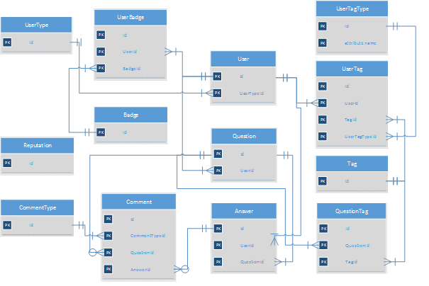
Since this program stores all data in a database, a database table column stands for
every array of data flow diagram.

DataItem | Attribute | Data Type and Size
UserType | Id | Int
UserType | Name | Varchar(50)
User | Id | Guid
User | UserTypeId | Int
User | Name | Varchar(50)
User | Surname | Varchar(50)
User | Mail | Varchar(50)
User | Password | Varchar(40) => Sha1
User | Username | Varchar(30)
User | Reputation | int
User | RegisterDate | Datetime
Question | Id | Guid
Question | UserId | Guid
Question | Title | Varchar(200)
Question | Text | Varchar(MAX)
Question | CreateDate | Datetime
QuestionTag | Id | Guid
QuestionTag | QuestionId | Guid
QuestionTag | TagId | Int
Tag | Id | Int
Tag | Name | Varchar(50)
UserBadge | Id | Guid
UserBadge | UserId | Guid
UserBadge | BadgeId | Int
Badge | Id | Int
Badge | Name | Varchar(50)
Badge | InformationText | Varchar(MAX)
Badge | ImagePath | Varchar(100)
Answer | Id | Guid
Answer | UserId | Guid
Answer | QuestionId | Guid
Answer | Text | Varchar(MAX)
Answer | CreateDate | Datetime
Comment | Id | Guid
Comment | CommentTypeId | Int
Comment | QuestionId (nullable) | Guid
Comment | AnswerId (nullable) | Guid
Comment | Text | Varchar(MAX)
Comment | CreateDate | Datetime
CommentType | Id | Int
CommentType | Name | Varchar(50)
UserTag | Id | Guid
UserTag | UserTagTypeId | Int
UserTag | TagId | Int
UserTag | UserId | Guid
UserTagType | Id | Int
UserTagType | Name | Varchar(50)
Reputation | Id | Int
Reputation | Name | Varchar(50)
Reputation | InformationText | Varchar(MAX)
Reputation | Value | Int

2.3 Standard interface description
The interface description describes the design of internal module interfaces, external
system interfaces, and the human/computer interface.
Default operating system hardware (keyboard, mouse, printer etc.) could be regarded as hardware interfaces.
Software interfaces are O.S (Windows 8), database server (SQL Server 2012), Visual Studio 2012/2013 and .NET Framework 4.5 for application to run.
Human interfaces: Web application of for admins, users and everyone.
Web application includes:
- Admin: Badge Add/Edit/Delete/List Page
- Admin: Tag Add/Edit/Delete/List Page
- Admin: Question Delete
- Admin: User List/Delete
- User: Question Add/Edit/List
- User: Comment Add/Edit/Delete/List
- User: Answer Add/Edit/List/Delete
- User: Interesting Question List Page
- User: Profile Edit/List Page
- User: Favourite Tag List Page
- Everyone (un-registered visitors): Question and Answer List Page

3. FUNCTIONAL DESCRIPTION
“Q&A” has two main functions:
- Database
Database queries will provide requested data efficiently and correctly. To achieve all this, normalized forms will be used in the database.
- Web application
Web application is used by all users. The application will provide an interface that will request data from and add new data to database. What each type of user can do is listed just above.
3.1 Functional partitioning
3.1.1 Database functional part module

This module is one of the most important module of the project. This project is a social platform therefore there can be many users, questions, answers etc. The software should be able to response to the requests with huge data as well as the maintability of the project should be satisfied. That is why the database access will be handled as separate module in project. Also there will be a class library project in the solution. This module can also be called as “Data Access Layer”. “Entity Framework” will be used as “Object Relational Mapper” in the project to decrease effort of developing Data Access Layer. Thus, after the table design tables will be created on MSSQL, the database will be mapped to the project, and classes will be generated by Entity Framework according to database tables.
The chart below main functionality of the Entity Framework. It will be an abstraction between application and database.

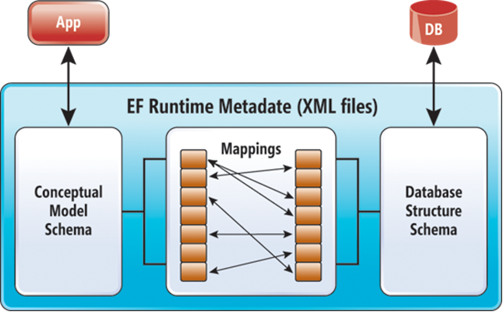
We will only develop the LINQ queries to get the data on web application. We will not interested in how an object in the application side can be written to the database with SQL queries.
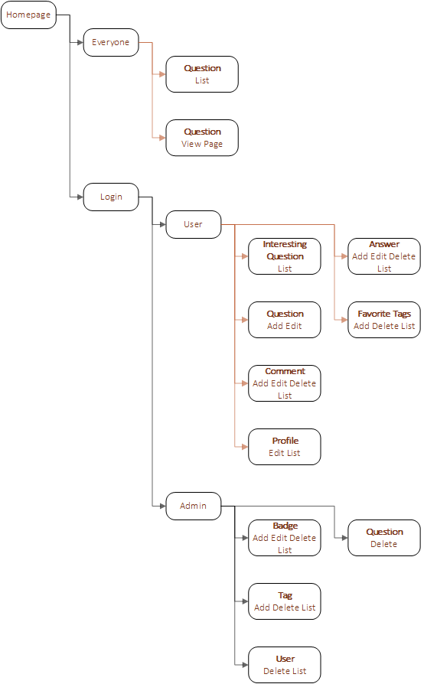
Entity Framework is successful with big data by using different approaches. A normalized database design and Entity Framework as Data Access Layer can work perfectly for this project.

3.1.2 Web Application functional part modules
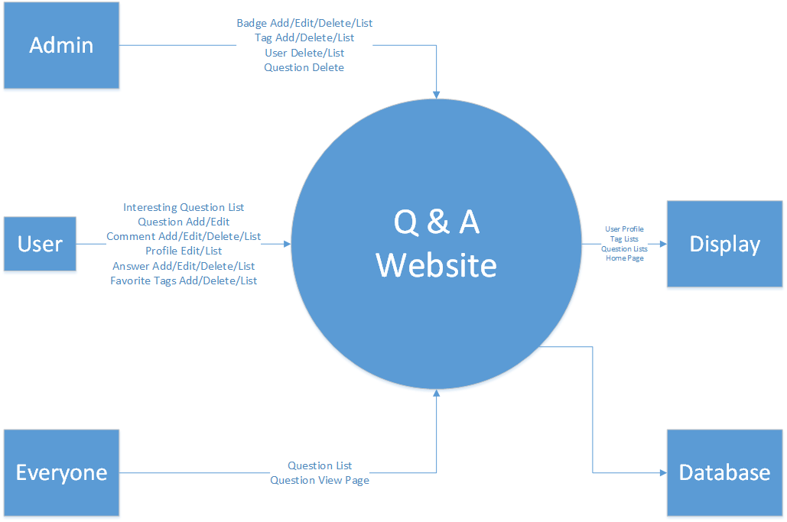
Data Flow Diagram for Web Application (Level 0)

*Each module can be used after successful login operation.
*Admin and User modules can be used only with a successful login. They can access only the related pages. Main security handlers will be implemented for this requirement.
Admin
This abstraction is the part of the web application that administrators can add, edit, delete and list tags and badges. Also admins can delete questions and users via this part.
Badge Add/Edit/Delete/List:
This module is a part of Admin pages. Admin can add new badge or edit an existing badge by entering its name, image path, and information text explaining how users can gain this badge.

TagAdd/Edit/Delete/List:
This module is a part of Admin pages. Admin can add new a tag or edit an existing tag by entering its name and information text revealing the clue about the contents of the question that is asked.
Question Delete:
This module is a part of Admin pages. Admin can delete any questions by giving the QuestionId as querystring. This page will be called with a link on Question View Page. Only admins can delete questions. Users can not delete any questions even their own questions.
User List/Delete:
This module is a part of Admin pages. Admins can list whole users on “User List Page” and can see their profile pages via a link included in it. Also admins can delete any users by giving the UserId as querystring on “User Delete Page”. This page will be called with a link on User Profile Page. Only admins can delete users. Users can not delete themselves.

Data Flow Diagram for Admin (Level 3)
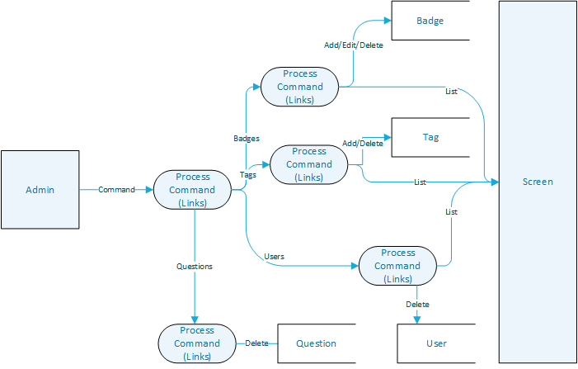

User
This abstraction is the part of the web application that users can add, edit, delete and list their questions, answers and comments. Also users can add or edit their profile information.
Profile:
This module is the part of web application in which the users can see and edit their profile information such as their contact, biography, location and website. Users also can see their site status information such as previous answers, badges, tags and reputations.
Question:
This module is the part of web application in which users can list question’s titles, tags and question’s text itself but not the answers of questions. Also every question has vote number, answers number, view number and date on the near of question title. Users can access to specific question page to click on “List answers button”.
Question Answer Add/Delete/Edit/List:
This module is the part of web application in which the users can see answer list and create, update or delete answers. If user wants to create an answer for a question, user uses this module and creates an answer. . If user wants to update his/her an answer for a question, user uses this module and updates this answer. . If user wants to delete his/her an answer for a question, user uses this module and delete this answer. This module has different pages for these three answer operations.
Interesting Question List Page:
This module is the part where the questions are listed according to users’ favorite tags. Each user has a favorite tag list which he/she creates. Based on this list, most appropriate results which are related to the tags are listed on this page. The module consists of only one page which contains the list of questions that are clickable. Also, the page is accessed via the button “Interesting” on the home page.
Question Comment Add/Delete/Edit/List:
This module is the part of web application in which the users can see comment list and create, update or delete comments. If user wants to create a comments for a question, user uses this module and creates a comment. . If user wants to update his/her a comment for a question, user uses this module and updates this comment. . If user wants to delete his/her a comment for a question, user uses this module and delete this comment. This module has different pages for these three comment operations.
Favorite Tag List (Add/Delete/List):
This module is the part of web application in which the users can see his/her favorite tag list and add or delete them. If user wants to add a tag to his/her favorite tag list, user uses this module and add this tag. If user wants to delete a tag to his/her favorite tag list, user uses this module and delete this tag. This module has different pages for these two tag operations.

Questions List Page :
This module is the part where the questions are listed according to users’ ignored tags. Each user has an ignored tag list which he/she creates. Based on this list, the results which exclude the questions with ignored tags are listed on this page. The module consists of only one page which contains the list of questions that are clickable. Also, the page is accessed via the button “Ignored” on the home page.
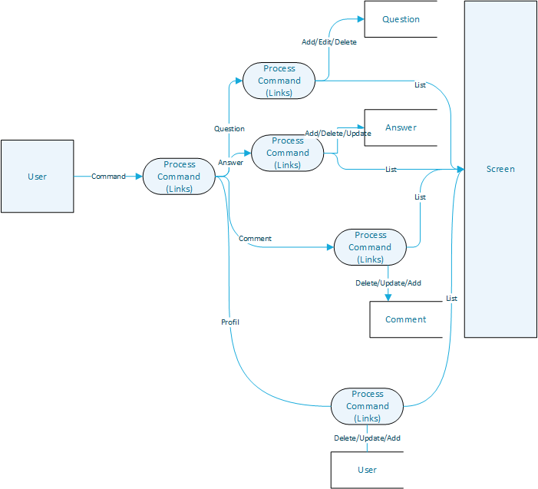
Data Flow Diagram of User (Level 3)

Everyone
This abstraction is the part of the web application which is admins and users can use commonly these modules.
Question View: This module is the part of web application which users and admins can see question title, question text itself, question tags, user who asked the question, date and comments. Other users can answer, comment, up vote, down vote .
User Login: This module is the part of the web application where the users enter their user information and granted access to user-only contens of the website.

Data Flow Diagram for Everyone (Level 3)

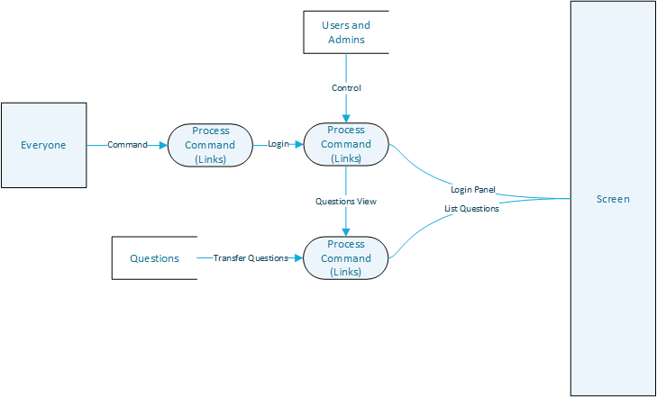

3.2 Functional Descriptions
3.2.1 Database Functional Description
All the DFD’s modules are described below in their section .
3.2.1.1 Module MSSQL database:
3.2.1.1.1 Processing narrative:
This module is one of the most important module of the project. This project is a social platform therefore there can be many users, questions, answers etc. The software should be able to response the requests with huge data as well as maintability of the project should be satisfied.
3.2.1.1.2 Restrictions and limitations
SQL Server 2012 Express is not capable of working with such large scale data and have some limitations on functionality due to being free. Hence, SQL Server 2012 will be used with a licence from DreamSpark or yazilim.cc.itu.edu.tr
3.2.1.1.3 Performance requirements
The Database should be large enough to hold the information about all the users, questions, answers, comments etc. Since the database should be fast enough to provide the appropriate results to the queries. We estimate that SQL Server 2012 has fairly enough capacity to handle these operations in miliseconds. In order to improve the performance, some columns on some tables will be indexed.
3.2.1.1.4 Design constraints
Before the database is implemented, the tables forming the database should be
evaluated with all the details, and should be normalized and split into more tables if needed.
The operations which remove or update any information on the database should be
analyzed carefully and appropriate constraints for these situations should be implemented.
Generally these kinds of queries should be restricted.

3.2.2 Web Application Description (module by module)
3.2.2.1 Module Badge Add/Edit/Delete/List (Admin)
3.2.2.1.1 Processing narrative
This module is a part of admin pages. Admins will list all the badges, then will select one of them by clicking edit, or delete links in the related rows. Admins can add new badges too. Edit/Delete pages will take BadgeId as input. In input will be provided to the links in the List page. Add and Edit pages will ask Name, Image Path and Information Text in a form to admin.
3.2.2.1.2 Restrictions and limitations
This module should check if any of the users have the selected badge in delete page. The software should inform the admins that some users will be affected from this operation.
Only admin can access these pages.
3.2.2.1.3 Performance requirements
These pages will be used by admins only, probably at the beginning of production. Thus, they don’t have any performance requirents that should be handled seperately.
3.2.2.1.4 Design constraints
Unauthenticated users mustn’t have access to pages. Only users with UserType equal to Admin can access. Images should be stored in file system instead of database because too many requests will be handled to badge images.
3.2.2.2 Module Question Delete (Admin)
3.2.2.2.1 Processing narrative
This module is a part of admin pages. Admins can delete questions. Delete Question Page will take QuestionId as parameter in querystring. This page will be called from Profile Page.

3.2.2.2.2 Restrictions and limitations
There is no restriction or limitation in this module.
3.2.2.2.3 Performance requirements
This module will be used by admins only and will not be used too much, thus performance is not such an important criteria.
3.2.2.2.4 Design constraints
Unauthenticated users mustn’t have access to pages. Only users with UserType equal to Admin can access.
3.2.2.3 Module User List/Delete (Admin)
3.2.2.3.1 Processing narrative
This module is a part of admin pages. Admins will list all the users, then will select one of them by clicking profile links in the related rows. In profile page of users there will be link to delete users which redirects to User Delete Page. This page will take UserId as parameter in querystring.
3.2.2.3.2 Restrictions and limitations
Delete link on the User Profile Page must only be visible to the admins.
3.2.2.3.3 Performance requirements
This module will be used by admins only and will not be used too much, thus performance is not such an important criteria.
3.2.2.3.4 Design constraints
Unauthenticated users mustn’t have access to delete page. Only users with UserType equal to Admin can access.

3.2.2.4 Module Tag Add/Edit/Delete/List (Admin)
3.2.2.4.1 Processing narrative
This module is a part of admin pages. Admins will be able to list all the question tags, and then will select one of them by clicking edit or delete links in the related rows of the resulting listing. Admins are able to add new tags as well as editing or deleting tags. Add and edit pages will provide the admin a form containing the Name and Information field of the badge while Edit and Delete pages will take TagId as input.
3.2.2.4.2 Restrictions and limitations
This module will check if any of the users have the selected tag in delete tag page. The software should inform the admins that whether users will be affected by this operation or not. Since this is an administration page, only admin priviledged users will be able to access these pages.
3.2.2.4.3 Performance requirements
No performance requirements are necessary.
3.2.2.4.4 Design constraints
Users with incorrect priviledges should not access to these pages. Only the users with UserType of type `Admin` can access those pages. Information text will be stored as string in database
3.2.2.5 Profile (User)
3.2.2.5.1 Processing narrative
This module is the part of web application in which the users can see and edit their profile information such as their contact, biography, location and website. Users also can see their site status information such as previous answers, badges, tags and reputations. In user profile page users can list questions, answers and tags via their links.

3.2.2.5.2 Restrictions and limitations
Users who view their own profile can add, update and delete their own profile information. Furthermore, others users and admins cannot add, update or delete other users profile. They can only see other user’s profile. Admins can only delete whole user account.
3.2.2.5.3 Performance requirements
This module will not be used as much as the question and answer modules, thus performance is not such an important criteria. But reducing waiting time is relatively significant.
3.2.2.5.4 Design constraints
A user will be able to perform the actions below:
• Could see and edit their full profile informatin
• Only view other users profile information.
3.2.2.6 Question (User)
3.2.2.6.1 Processing narrative
This module is the part of web application in which users can list question’s titles, tags and question’s text itself but not the answers of questions. Also every question has vote number, answers number, view number and date on the near of question title. Users can access to specific question page to click on “List answers button”.
3.2.2.6.2 Restrictions and limitations
Users who view their own questions can update and delete their own questions. Furthermore, others users cannot add, update or delete other users questions. They can only see other user’s questions and answer or comment them.
3.2.2.6.3 Performance requirements
In this module, there are lots of MSSQL queries to provide a lot of information about questions related data. Questions and answers are main objects of the whole project so that it must be flawless.

3.2.2.6.4 Design constraints
A question can be evaluated as:
• Question can be added, updated and edited by its owner user
• Questions can be view by all users and admins
• Admins can delete question
3.2.2.7 Module Question Answer Add/Delete/Update/List (User)
3.2.2.7.1 Processing narrative
This module is the part of web application in which users can process on questions (listing, creating, updating, and deleting). Users can do this operations with connecting between Question Answer CRUD page and other pages.
3.2.2.7.2 Restrictions and limitations
If users do not has any answers, they can do only create answer, not update, delete or list answer.
3.2.2.7.3 Performance requirements
To ensure quality of service this module should provide fast and accurate about the answer processes. Reducing waiting time is important for the admins and users
3.2.2.7.4 Design constraints
This module is using for that users can process on their answers so users can not step in other users’ answers.

3.2.2.8 Question Comment Add/Delete/Edit/List(User)
3.2.2.8.1 Processing narrative
This module is the part of web in which users can process on comments (listing, adding, updating, and deleting). Users can do this operations with connecting between Question Answer CRUD page and other pages (adding, deleting and editing pages).

3.2.2.8.2 Restrictions and limitations
If users does not has any comments, they can do only create answer, not update, delete or list comments.
3.2.2.8.3 Performance requirements
To ensure quality of service this module should provide fast and accurate about the comment processes. Reducing waiting time is important for the admins and users.
3.2.2.8.4 Design constraints
This module is using for that users can process on their comments so users can not step in other users comments.
3.2.2.9 Module Favorite Tag List (User)
3.2.2.9.1 Processing narrative
This module is the part of web application in which users can process on their tags (listing, adding, or deleting). Users can do this operations with connecting between Favorite Tag List page and other pages (adding, listing and deleting pages).
3.2.2.9.2 Restrictions and limitations
If users do not has any tags, they can do only add tag, not delete or list tags. In addition, users never update tags.
3.2.2.9.3 Performance requirements
To ensure quality of service this module should provide fast and accurate about the tag processes. Reducing waiting time is important for the admins and users.
3.2.2.9.4 Design constraints
This module is using for that users can process on their tags so users can not step in other users’ tags.

3.2.2.10 Module Ignored Tag List
3.2.2.10.1 Processing narrative
This module is the part of web in which users can process on their tags (listing, adding, or deleting). Users can do this operations with connecting between Ignored Tag List page and other pages (adding, listing and deleting pages).
3.2.2.10.2 Restrictions and limitations
If users do not has any tags, they can do only add tag, not delete or list tags. In addition, users never update tags.
3.2.2.10.3 Performance requirements
To ensure quality of service this module should provide fast and accurate about the tag processes. Reducing waiting time is important for the admins and users.
3.2.2.10.4 Design constraints
This module is using for that users can process on their tags so users can not step in other users’ tags.
3.2.2.11 Interesting Questions List Page
3.2.2.11.1 Processing narrative
This module is the part web application in which the users may retrieve a list according to their favorite tags. Users can do this with just clicking on the “Interesting” button, which is a query on the questions.
3.2.2.11.2 Restrictions and limitations
There are no limitations in general, users can add as many favorite tags as desired and view the interesting questions list page. But there are two extreme cases. One of them is the case where user has no tags at all. In this case, the interesting questions list page shall be empty. Other one is the case where there are no corresponding questions with the tags of the user. This case shall also yield an empty page. Briefly there are no limitations, however there is a chance of an empty interesting questions list page.

3.2.2.11.3 Performance requirements
To ensure quality of service this module should provide fast and accurate about the tag processes. Reducing waiting time is important for the admins and users.
3.2.2.11.4 Design constraints
A user can view only his/her interesting questions list page, even though he/she may view other users’ favorite tags list.
3.2.2.12 Question View (Everyone)
3.2.2.12.1 Processing narrative
This module is the part of web application which users and admins can see question title, question text itself, question tags, user who asked the question, date and comments. Other users can answer, comment, up vote, down vote .
3.2.2.12.2 Restrictions and limitations
Both users and admins can view question itself and questions additional informations such as; question’s title, question’s actual text, question’s tag, user who asked the question, date and upvote downvote buttons.
3.2.2.12.3 Performance requirements
In this module, there are lots of MSSQL queries to provide a lot of information about question’s data. Questions are the main objects of the whole project so that it must be run flawless.
3.2.2.12.4 Design constraints
All questions can be viewed by users and admins. But user who asked the questions can be edit or delete their own questions. Admins cannot edit user’s question but they can delete the whole question.

3.2.2.13 Login Module
3.2.2.13.1 Processing narrative
This module lets the user to access user-only part of the webpage. In login screen, user is asked for user name and password. After submission, input control is made: UserName and Password entered are compared with the database. Among correct input entry, user is granted the user-only content of the webpage system.
3.2.2.13.2 Restrictions and limitations
A user should not be granted user-only contents of the system, i.e. log in, by entering faulty information. Only correct UserName and UserPassword entries should be logged in. A user with same e-mail address may not have multiple accounts.
3.2.2.13.3 Performance requirements
User Login does not require and performance.
3.2.2.13.4 Design constraints
Only valid e-mail formats should be entered to the UserName input, thus the module should check for the text entered to form. SQL Injection should be checked as well for security purposes.
3.3.2 Web application modules:
      - Badge Add/Edit/Delete/List Module (Admin):
Control Specification:
- Control Inputs: UserType of logged in user, related questions while deleting
- Control Outputs: Priveleged user authentication, inform admin, Badge informations on list/add/edit pages.
      - Question Delete Module (Admin):
Control Specification:
- Control Inputs: UserType of logged in user
- Control Outputs: Priveleged user authentication
      - User List/Delete Module (Admin):
Control Specification:
- Control Inputs: UserType of logged in user
- Control Outputs: Priveleged user authentication , User profile informations
      - Tag
Control Specification:
- Control Inputs: UserType of logged in user, related questions while deleting tag
- Control Outputs: Priviledged user authentication, inform admin, Tag information on list/add/edit pages.
      - Profile (User)
Control Specification:
- Control Inputs: User_ID, viewer User_ID
- Control Outputs: Displays user profile information on the screen
3.3.2.6 Question (User)
Control Specification:
- Control Inputs: Question_ID, viewer User_ID
- Control Outputs: Question information to the screen
3.3.2.7 Question Answer Add/Delete/Update/List (User)
Control Specification:
- Control Inputs: Question_ID, Answer_ID, viewer User_ID
- Control Outputs: Displays answer information on the screen
3.3.2.8 Question Comment Add/Delete/Edit/List (User)
Control Specification:
- Control Inputs: Question_ID, Comment_ID,
- Control Outputs: Display comment information on the web page

3.3.2.9 Module Favorite Tag List (User)
Control Specification:
- Control Inputs: Tag_ID, User_ID, viewer User_ID
- Control Outputs: Shows favorite tag information to the screen
3.3.2.10 Module Ignored Tag List(User)
Control Specification:
- Control Inputs: Tag_ID, User_ID, viewer User_ID
- Control Outputs: Print ignored tag list to the screen
3.3.2.11 Interesting Questions List Page(User)
Control Specification:
- Control Inputs: Tag_ID, User_ID, Question_ID
- Control Outputs: Lists the interesting questions to the web page
3.3.2.12 Question View (Everyone)
Control Specification:
- Control Inputs: Tag_ID, User_ID, Question_ID
- Control Outputs: Lists the questions to the web page without ignored tags’ questions
3.3.2.13 User Login (Everyone)
Control Specification:
- Control Inputs: UserName and UserPassword
- Control Outputs: Displays question listing page

4. BEHAVIORAL DESCRIPTION
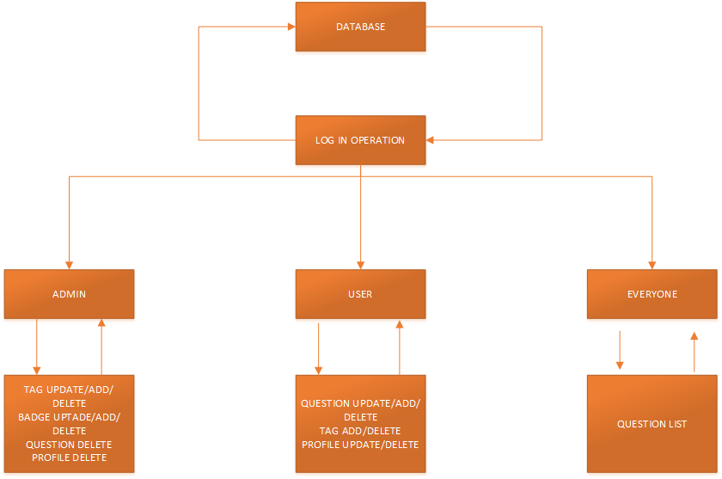
STD of “Q&A Web Page” web application is provided below.

5. VALIDATION CRITERIA
There are not important performance bounds for .NET Framework, and MSSQL
Server in normal circumtances. Network connection speed may be only limiting thing for
system usage. Test classes are not defined yet because software coding is not completed. There are 2 security based approaches: user name and password for login and prevention of SQL injection. Usability is another criterion. The website should be user-friendly, easy to browse to fulfill as many users’ needs as possible. Databases should be able to recover in a case of power cuttage or hardware failure.

